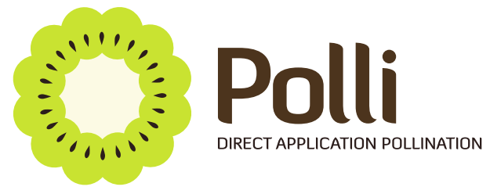

Polli – Direct Application Pollination
Profile

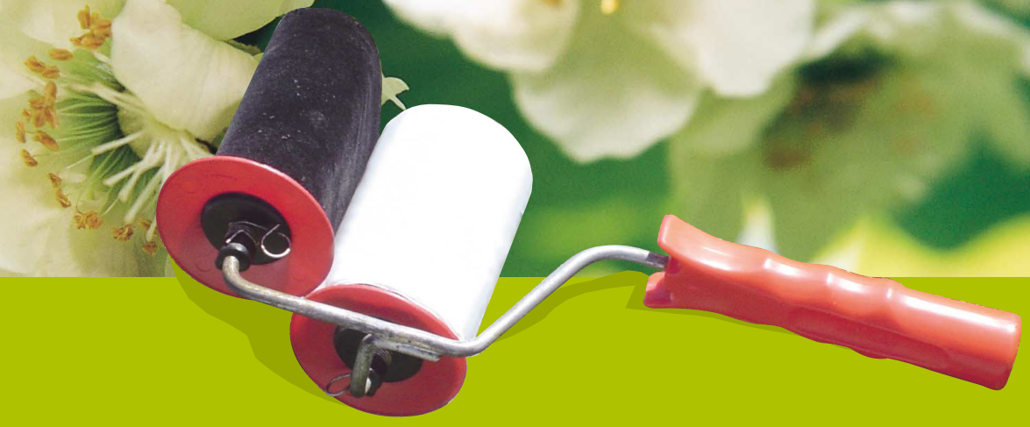

The Polli Direct Application Pollination System
Polli is a supplementary kiwifruit pollination method that involves the direct application of pollen to female flowers. Polli enables orchardists to improve pollination, increase fruit size and boost income.
It is well recognised that the most effective means of pollinating a female flower is hand pollination – taking a male flower and touching it against a female flower. The Polli pollination system effectively replicates hand pollination to achieve optimal pollination in a cost effective manner.
The Polli system involves impregnating a velvet strip with high viability pollen and supplying the product in a roll form. The Polli roll is applied using a Polli roll applicator tool.
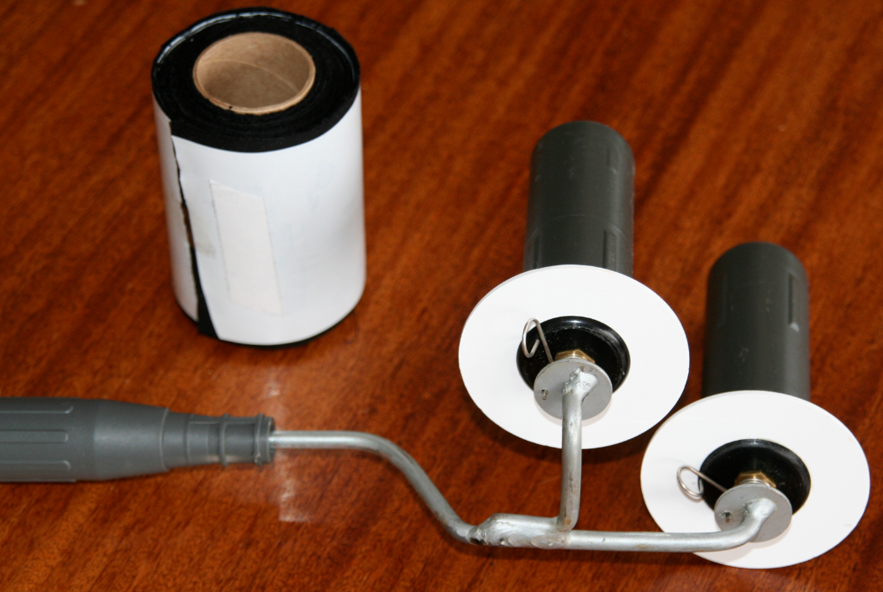
Polli roll and Polli applicator tool
The Polli roll is fitted to the applicator tool and applied using a wiping motion.
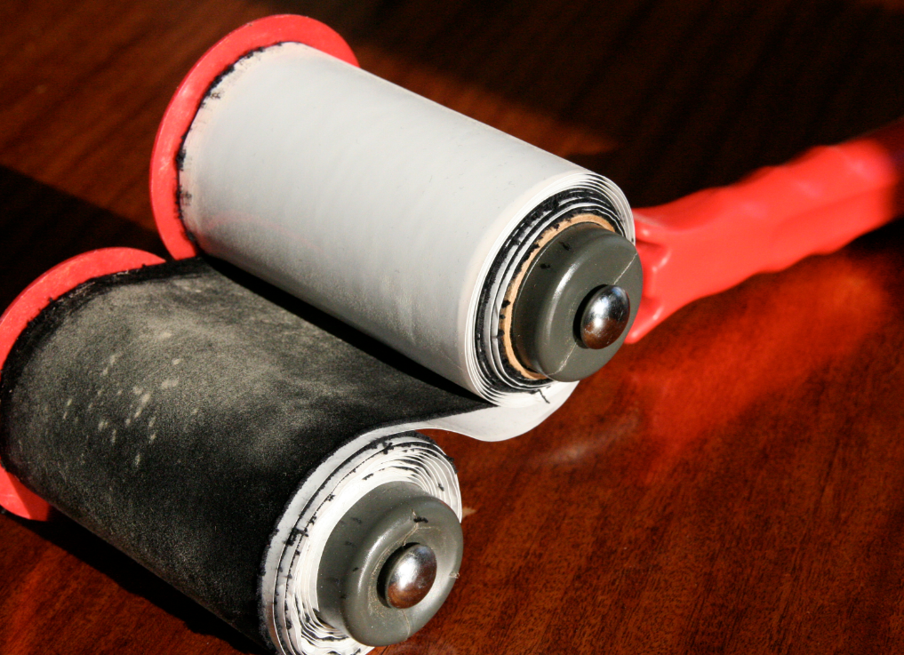
Polli tool with a Polli roll fitted

Each Polli roll contains approximately 6.5 grams of high viability pollen. The pollen is spread on a 3.3 metre strip of velvet during the production process.

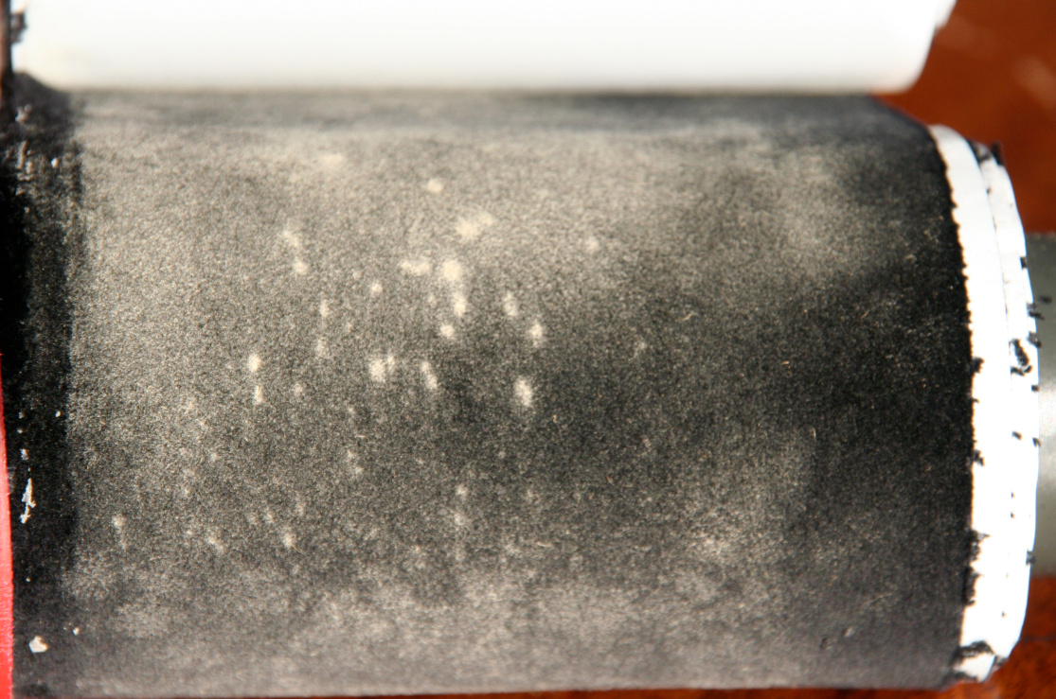
Close up view of pollen impregnated velvet

The Poll pollination system deposits high levels of staminate (male) pollen on the stigmas of pistillated (female) flowers and significantly increases fruit size.

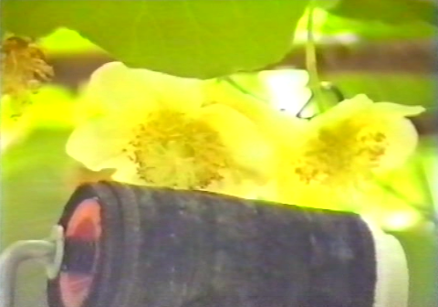
Pollination of a female flower using the Polli pollination system

As the Polli Roll is touched against female flowers, the stigmas drag through the velvet and pollen is transferred. Once no more pollen is visible on the velvet, the role is advanced to expose fresh pollen.
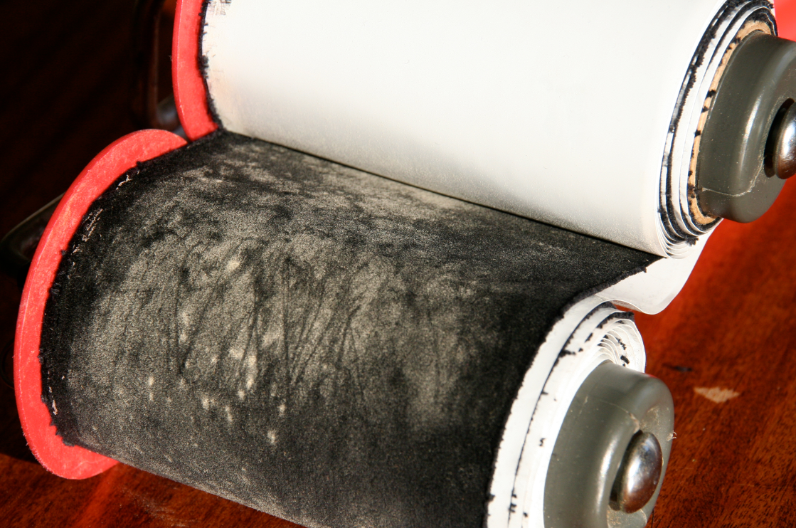
Lines are visible on the Polli roll where pollen has been transferred to female flowers

The Application Process

Application Method
Polli Rolls need to remain frozen until use so are best transported into the orchard in a chilly bin. The Polli Roll is quickly and easily inserted on to the applicator tool. Pollination is achieved by touching the female flowers with the pollen impregnated velvet in a wiping motion. Once pollen is used, simply advance the Polli roll to expose more pollen.
To achieve the best results, Polli Rolls should be applied at temperatures greater than 14 Degrees Celsius. Wet conditions should be avoided.

Application
A typical Polli application rate in New Zealand is 20 rolls per hectare. Application is completed in two passes. The first pass is at approximately 30-40 per cent flowering and the second at about 80 – 100 per cent. Areas of the orchards that flower early or later than the main area such as shelter belt rows can be pollinated in additional passes as desired.
In areas where there is no bee activity, Polli application needs to be modified. Additional rolls per hectare are required. Depending on flower numbers, up to 30 rolls per hectare may be required if bee activity is limited. It is also recommended that additional passes are completed so that early and late flowers are pollinated.

Application Training
A simple demonstration is all that is needed before a new applicator can be effectively pollinating using the Polli method. Pollination can be completed by individual growers or by a managed team of applicators.

The Results

MAF Research
A MAF team lead by pollination expert Dr. RM Goodwin conducted an evaluation of the Polli pollination system.
The conclusions of the evaluation were that:
- The Polli pollination system can deposit high levels of staminate pollen on the stigmas of pistillated flowers and significantly increase fruit size.
- Polli pollination is capable of producing an export size crop without additional honey bee pollination.
The findings of the research were that kiwifruit pollinated using the Polli Pollination System were on average 14 per cent heavier than Bee pollinated kiwifruit.

Loyal Customer Base
Polli Ltd enjoys a high level of customer loyalty with a large proportion of customers purchasing Polli rolls year on year. This high level of loyalty speaks volumes for the success of the product.

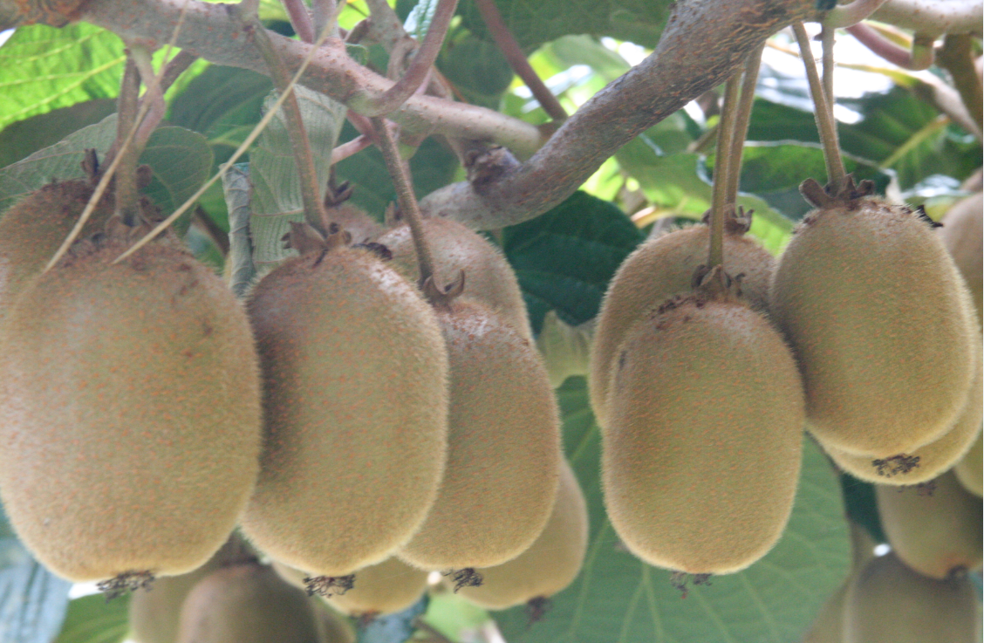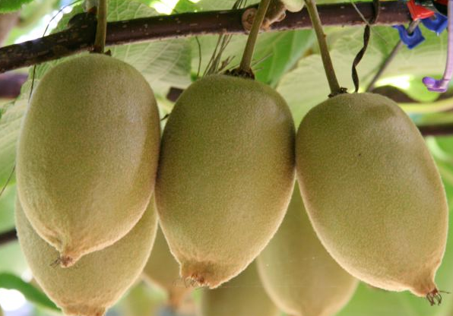

Benefits of Polli Pollination
Applying pollen directly to female flowers in a cost effective manner is the key advantage of Polli. Polli allows you to target pollination at optimal times by completing multiple application passes. Using Polli gives extremely high levels of pollination control as the only way to use pollen is to apply it to open flowers.
• Increased fruit size • Increased seed numbers • Increased dry matter
• Higher yield • Higher returns to the grower • Cost effective - no waste

